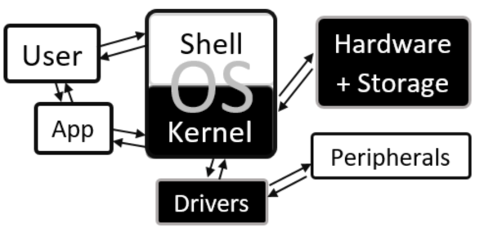

|  |  |  |  |
| --- | --- | --- | --- |
| **A** | | **Roles of an operating system** | |
| **1** | **Memory management** | | Allocation of RAM to all running programs using *paging* and *segmentation*. |
| **2** | **Multi-tasking** | | Running several different programs at the same time by switching between them very quickly (*scheduling*). |
| **3** | **User management** | | Allowing for different users to have different accounts, security and permissions |
| **4** | **Peripheral management** | | Allowing for applications to use peripherals via drivers and dealing with interrupts |
| **5** | **Utility management** | | Running and maintaining utilities |
| **6** | **CPU management** | | Running applications, executing and cancelling processes |
| **7** | **User Interface/ Shell** | | The means of communication between the user and the OS |
| **8** | **File management** | | Providing a file system for storage and retrieval of files |

Software: Operating Systems

|  |  |  |
| --- | --- | --- |
| **B** | **Key vocab** | |
| **Paging** | | Memory management technique which involves splitting RAM up into equal sized pages, and indexing them |
| **Segmentation** | | Memory management technique which involves programs into blocks of memory which fit the gaps in the RAM |
| **Scheduling** | | The process of arranging and controlling various processes when multi-tasking |
| **Multi-user** | | When more than one user has access to the same memory, storage or CPU time |
| **Kernel** | | The part of the operating system which interacts with hardware on one side and applications on the other |
| **Driver** | | Software which interfaces between applications and peripherals |
| **Buffer** | | A temporary area of computer memory used to store data for running processes. |
| **Interrupt** | | A signal to the OS to stop it running its current program, and instead run a particular driver |
| **GUI** | | Graphical User Interface (icons) |
| **CLI** | | Command Line Interface |
| **VUI** | | Voice User Interface |